TECHNICAL PROJECT REPORT

# Title of Invention / Project:Temperature control smart fan

# Team Members / Inventors:

|  |  |  |  |  |  |
| --- | --- | --- | --- | --- | --- |
| **S. No.** | **Name** | **Department** | **Designation** | **Mobile** | **E-Mail** |
| 1. | Tammireddy s sai datta venkat | CSE(IOT) | Student | 9515827738 | siddutssd@gmail.com |
| 2. | Chava rohith | CSE(IOT) | Student | 8106641687 | rohithchava2000@gmail.com |
| 3. | Masetty.Sai Sundar | CSE(IOT) | Student | 8790399320 | saisundarmasetty@gmail.com |
| 4. | Alokam nikita | CSE(IOT) | Student | 6281004545 | nikitaalokam@gmail.com |
| 5. | Pasang cheophel | CSE(IOT) | Student | 8278807473 | Pasangchoe1444@gmail.com |
| 6. | Khushal Thakur | ECE | Mentor | 9646030764 | khushal.thakur@cumail.in |
| 7. | Anshul Sharma | ECE | Mentor | 9478697475 | anshulsharma.ece@cumail.in |
| 8. | Kiran Jot Singh | ECE | Mentor | 9463909689 | kiranjotsingh.ece@cumal.in |
|  | Divneet Singh Kapoor | ECE | Mentor | 9878422653 | divneet.ece@cumail.in |

Section – 1 (IPR Related)

# Brief Abstract :

* Decreases the electricity consumption.
* By using temperature control sensor
* By making the circuit stronger so that it will not be affected by the heat absorbed by sensor.

# Existing state-of-the-art and Drawbacks in existing state-of-the-art

|  |  |  |
| --- | --- | --- |
| **S. No.** | **Existing state of art** | **Drawbacks in existing state of art** |
| 1 | Manual control | Its can only be controlled manually |
| 2 | Wifi connected fans | Needed android devices |

# Novel/Additional modifications that you can propose to improve upon drawbacks

* Automatic turn ON/OFF.
* It provide the required speed for the user .

# Advantages

* *It is very economical and easy to handle by the users.*
* *It is helpful to disable people*
* *Speed varies automatically so that it cannot be controlled manually .*

# Block Diagram

Section – 2 (Real Project)

# Materials

1.Arduino

2.Temperature Sensor LM35

3.DC Motor

4.1K resistance

5.Diode 1N4001

6.Transistor NPN 2N2222

7.9V Battery

8.Battery Cap

# Circuit Diagram

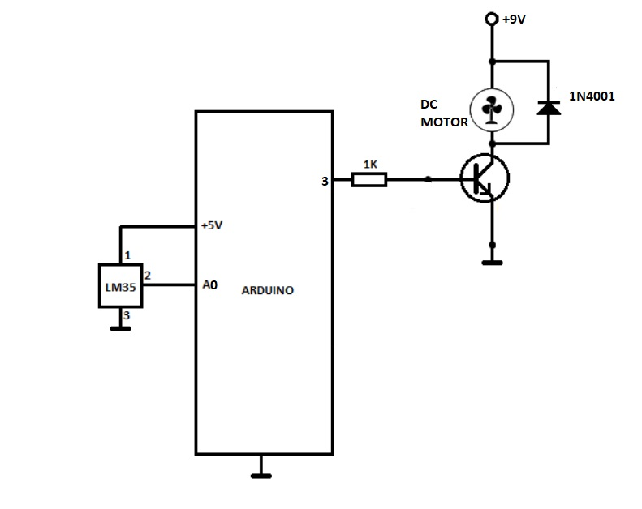

# Steps of Circuit Completion

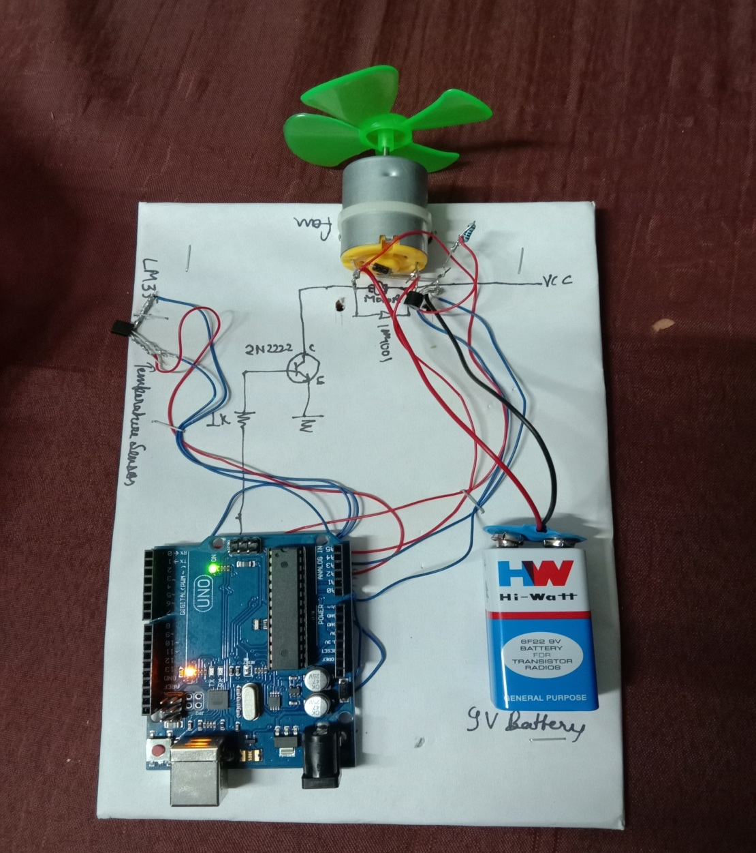

* Wire from fan connected to pin 3 of ardiuno,
* Single pin to LM35 is connected to A0 pin of ardiuno
* Another pin of lm-35 is connected to ground
* And diode is connected parallel to motor
* 1-end of transistor is connected to ground and one for the motor
* And 2 ends of the battery is connected to v(in) and ground

# Program Code

<https://gist.github.com/beeepro/67530fa28922f18cf105934f6d03b53d>